**Social Media Database - Phase 1**

***Description***

The description for the Social Media Database is as follows:

* Users are identified by a unique ID. Each user has a first name, last name, and email.
* Although users are allowed to like as many posts as they would like, they are not allowed to like a single post more than once.
* Multiple comments may be made to a single post by a single user.
* Users may respond to as many comments as they would like.
* Comments are identified by a unique ID. Each comment has the date, time, and the content of the comment. Comments may be made on comments.
* When a user likes a post, likes are identified by the ID of the user and ID of the post. Each like also includes a date and time.
* Each post that a user posts is identified by a unique ID. Each post may or may not have a single link and/or a single image. Included in each post is the date, time, content, and a title.
* A post may only be written by a single user.

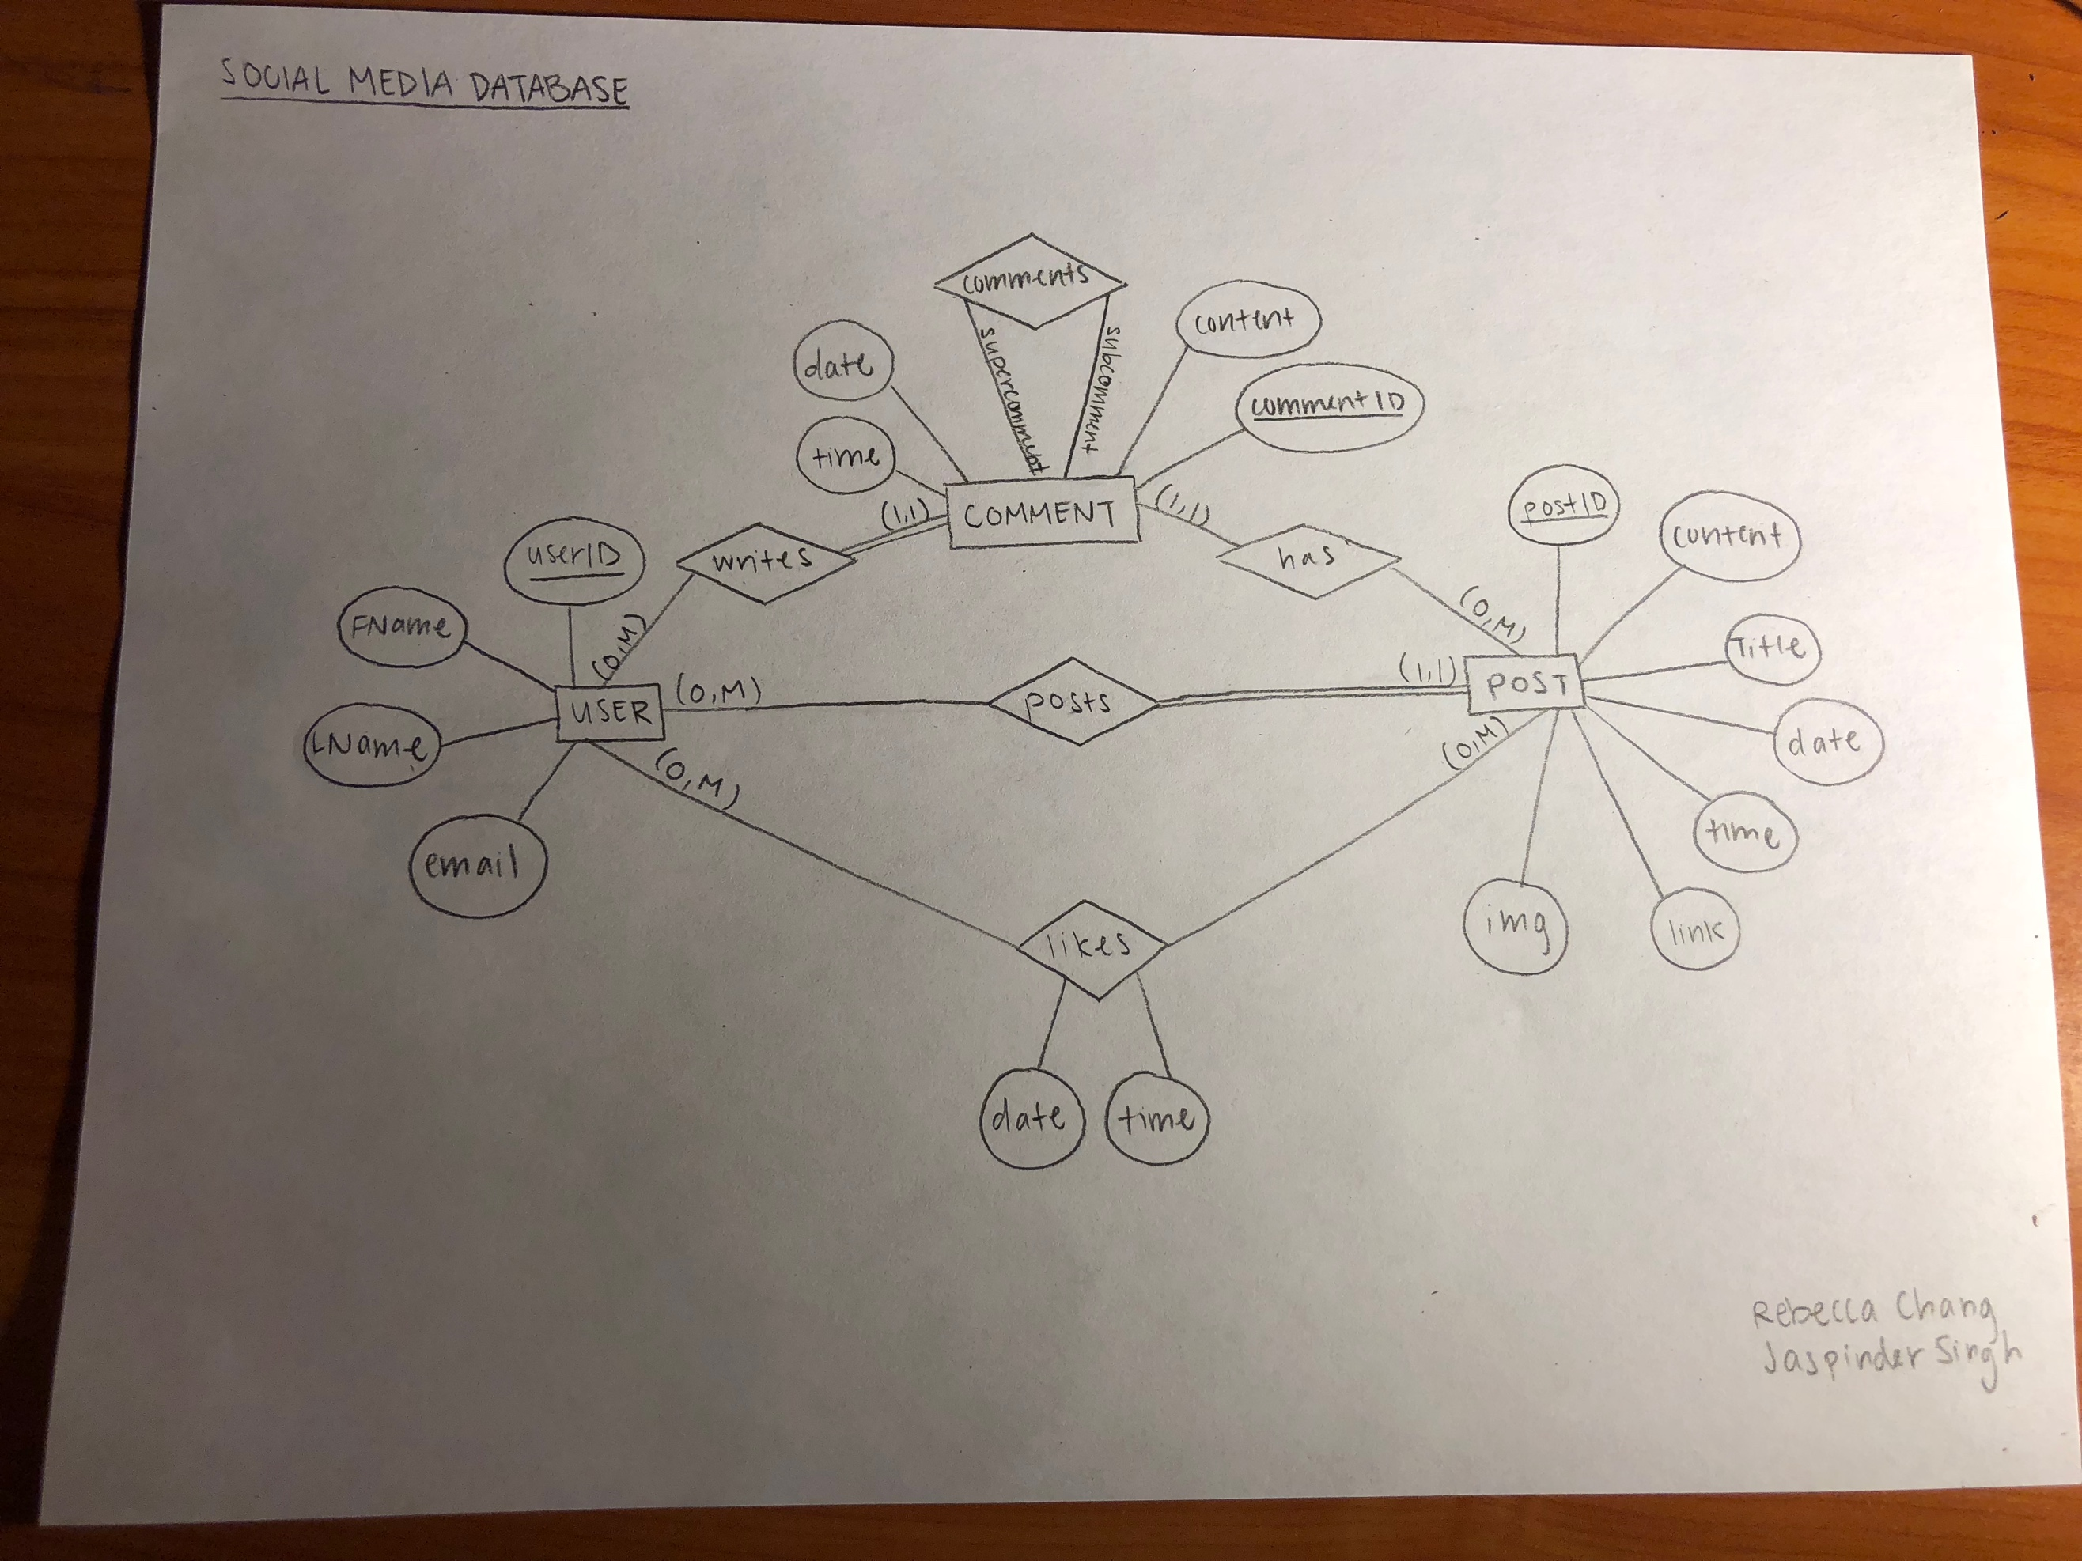

**SOCIAL MEDIA DATABASE - PHASE 2**

USERS(UserID, FirstName, LastName, Email)

* USERS is in 1NF because each attribute only holds one value
* USERS is automatically in 2NF because there is only one primary key, therefore there is no need to check for partial dependency
* USERS is in 3NF and BCNF because there are no transitive dependencies to check

Post(PostID, Content, Title, PDateTime, **UserID**)

* POST is in 1NF because each attribute only holds one value
* POST is in 2NF because all attributes depend on the primary key since there is only one primary key
* POST is in 3NF and BCNF because there are no transitive dependencies to check

COMMENTS(CommentID, CDateTime, Content, **UserID**, **PostID, HigherCommentID**)

* COMMENTS is in 1NF because each attribute has only one value
* COMMENTS is in 2NF because each Date, Time, Content, UserID, and PostID are unique to one comment. UserID is used to identify which user a comment belongs to, and PostID is used to identify which post a user is commenting on
* COMMENTS is in 3NF because there is no transitive dependency

LIKES(**UserID**, **PostID**, LDateTime)

* LIKES is in 1NF because each attribute has only one value
* LIKES is in 2NF because Date and Time each depend on the UserID and PostID combined in order to identify which like was made by which user and which post they liked on a specific Date and Time, therefore there are no partial dependencies.
* LIKES is in 3NF and BCNF because there are no transitive dependencies to check.

IMAGES(ImgPath, **PostID**)

* IMAGES is in all normal forms because each attribute only holds one value (1NF), and since there is only one primary key, we automatically know that there are no partial dependendencies (2NF), and there are no transitive dependencies to check (3NF and BCNF).

Link(URL, **PostID**)

* LINKS is in all normal forms because each attribute only holds one value (1NF), there is only one primary key (automatically 2NF because there is no partial dependency), and there are no transitive dependencies to check (3NF and BCNF).

**SOCIAL MEDIA DATABASE - PHASE 3 & 4**

For phase 3 and 4 of the social media project, please see the attached files for the scripts (phase 3) and queries (phase 4).